1.The screenshot taken of the officework’s filled and submitted registration page

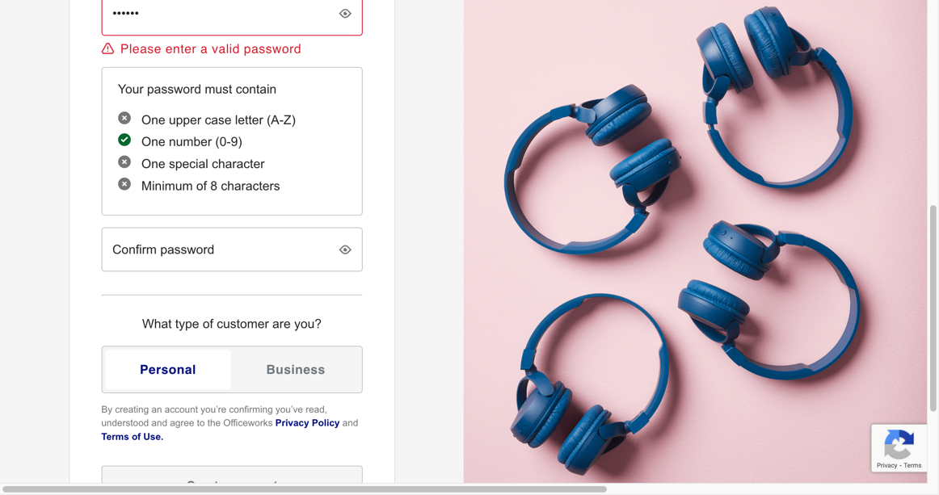

2.Repeat the above step for an alternative website’s registration page.

I have tried two separate website which are target and kmart, and I found that these two website createAccount is not like officework’s layout which is more straight forward, I need to write a clickButton function to direct to a new page to finalize my testing, but I’ve encounter some issues which requiring wait for some seconds to load in new page, and the rest of the code will throw an error shows couldn’t find firstname by id

(just because the java is running the code step by step without waiting, probably I need to write some of asynchronous function to solve this issue )

1. This is the inspection of Target Website

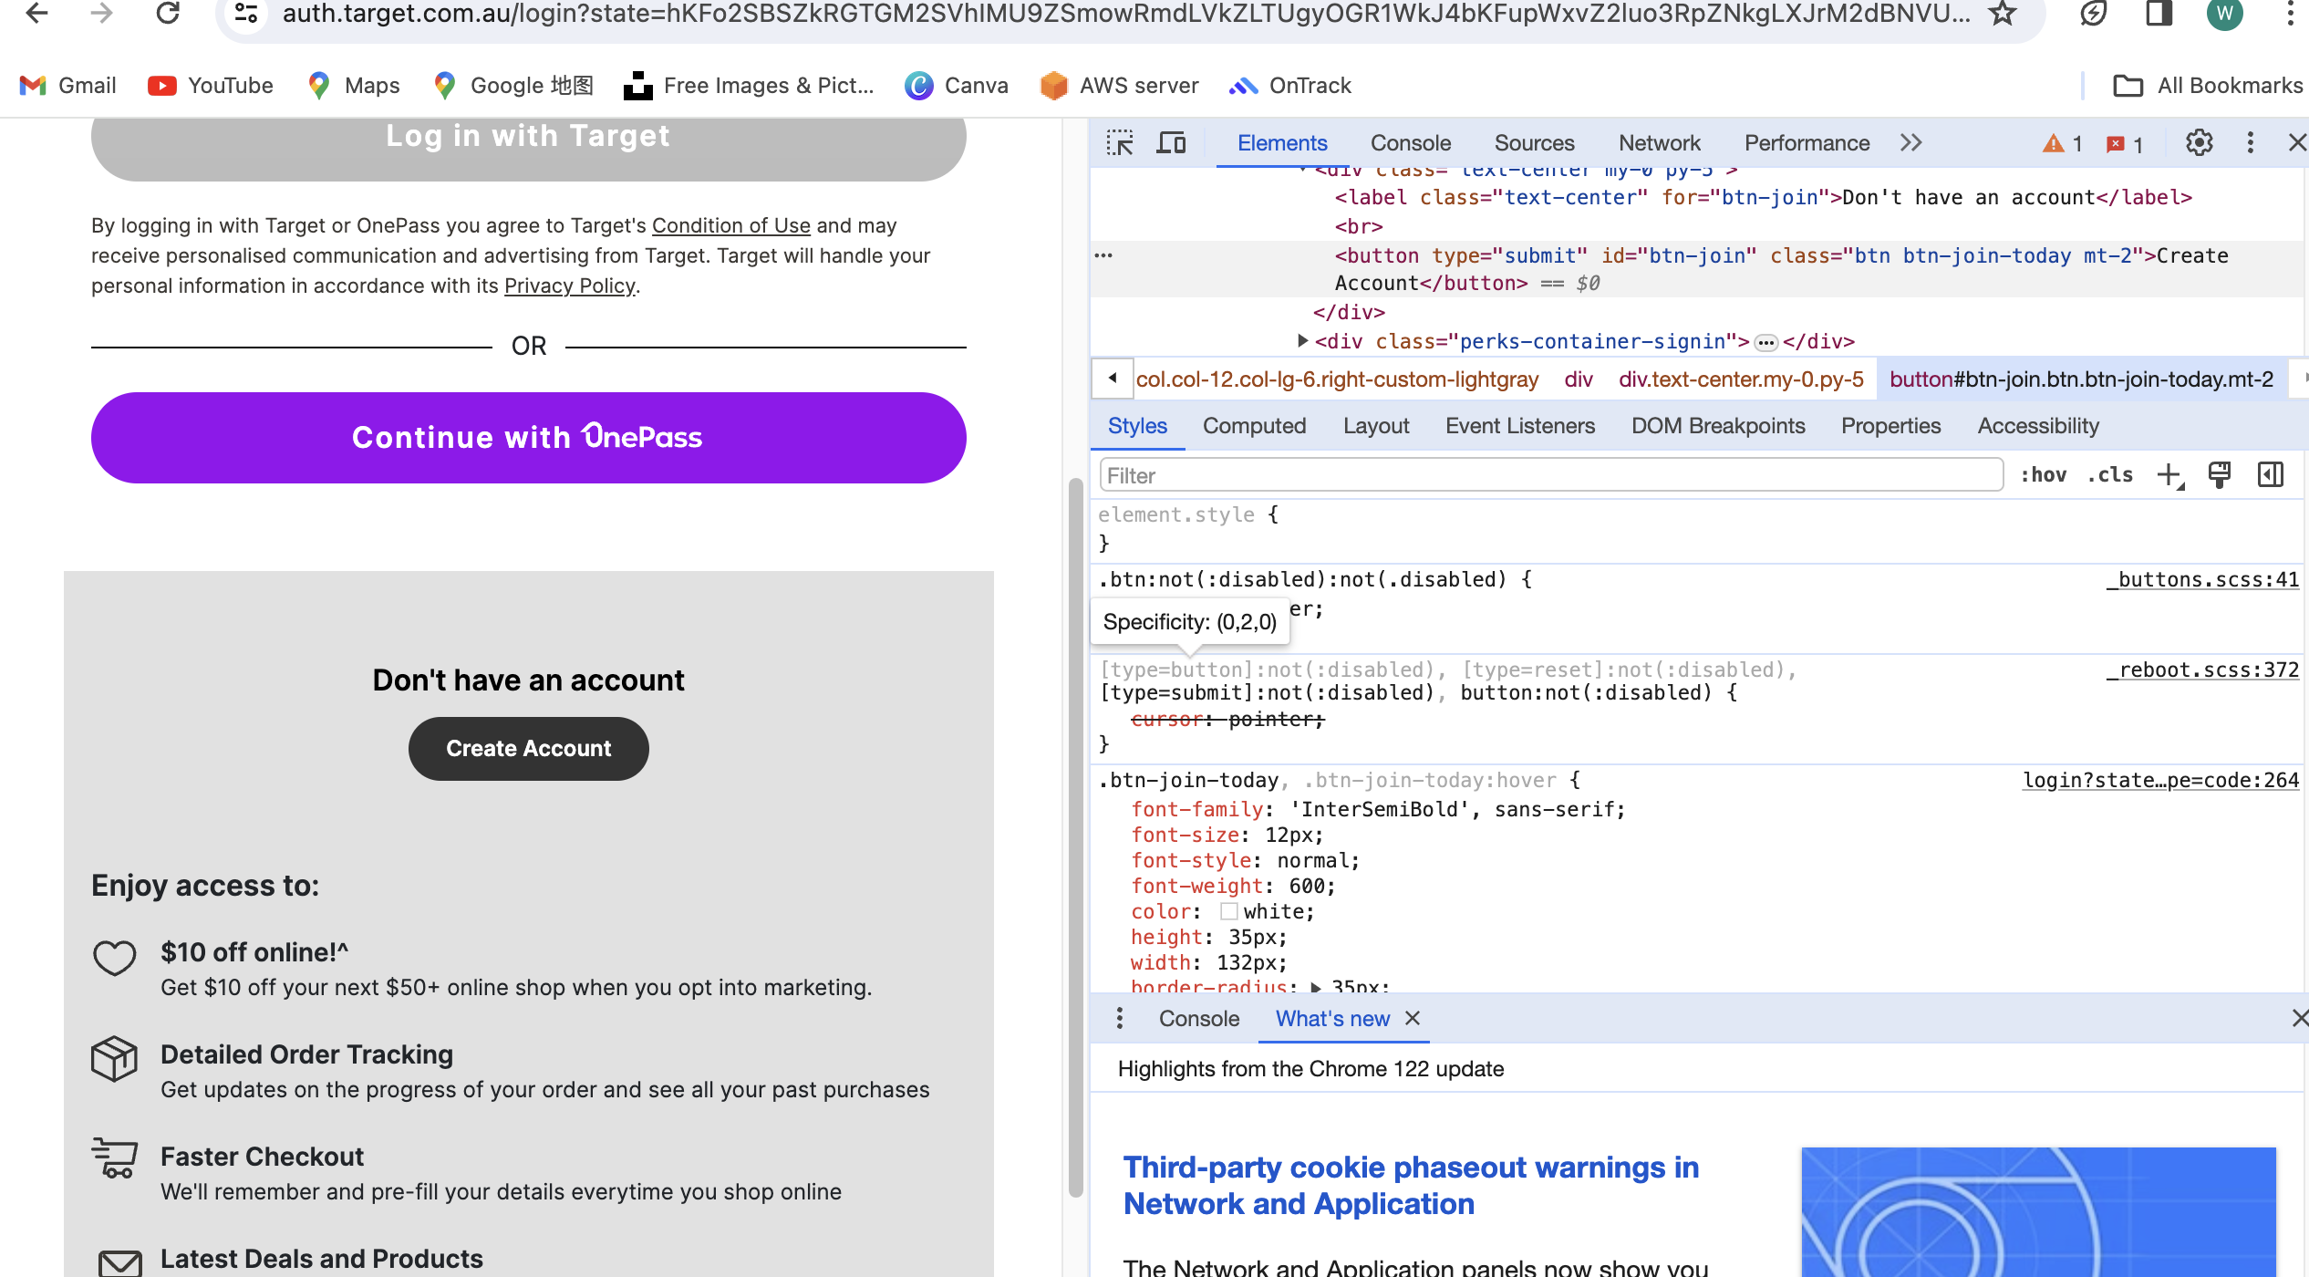

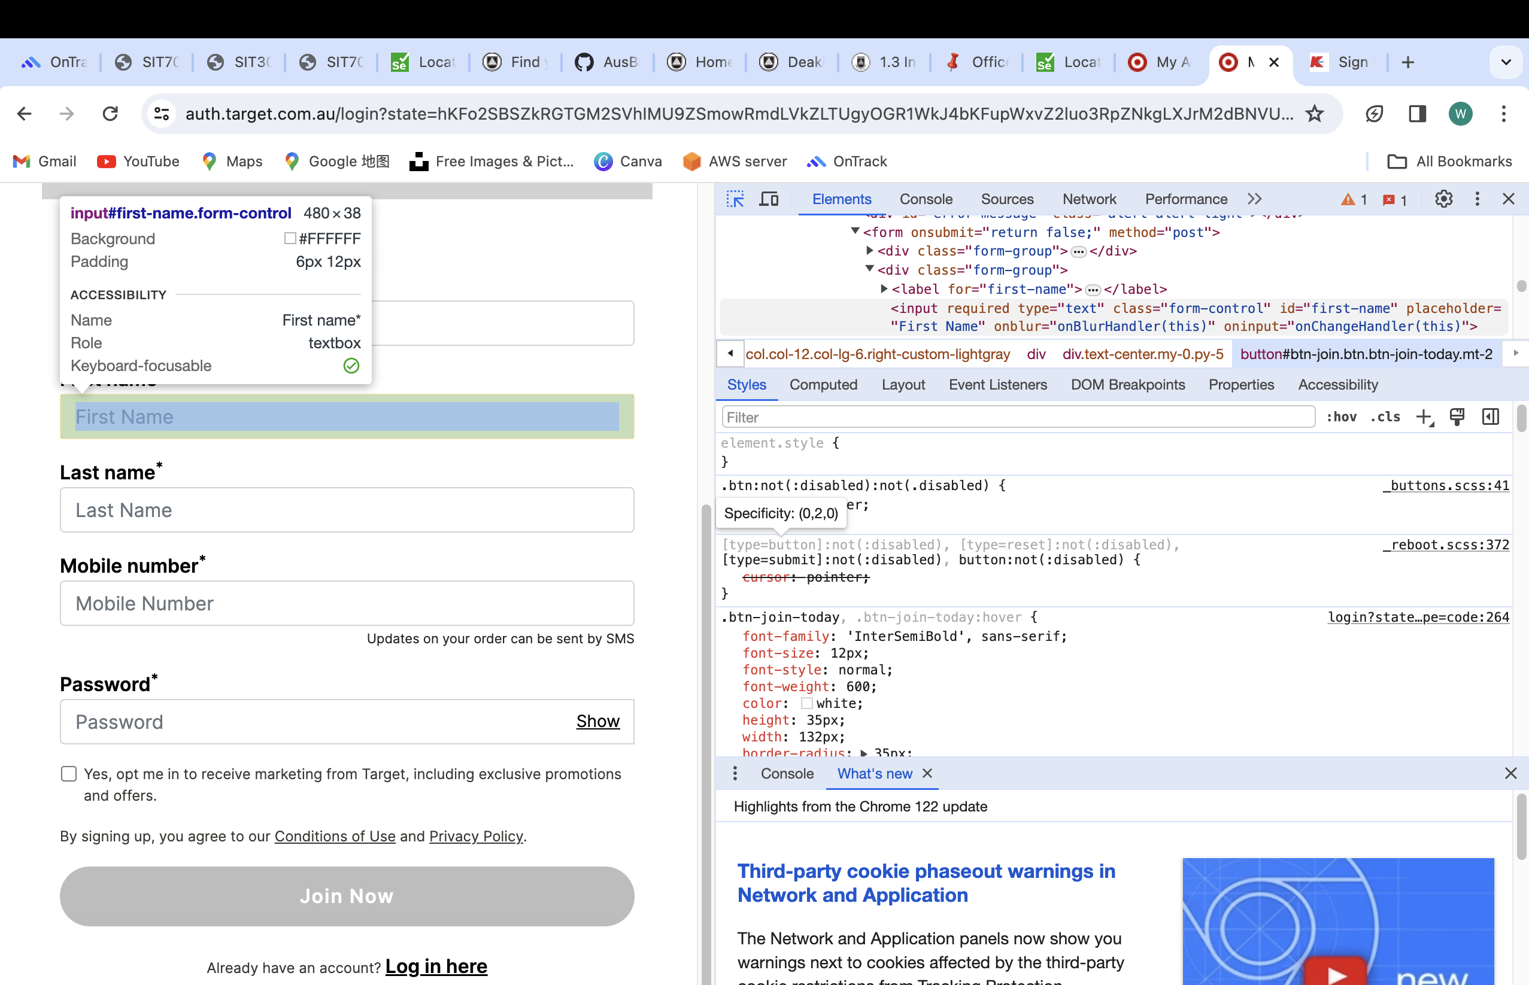

2.This is the inspection of Kmart website

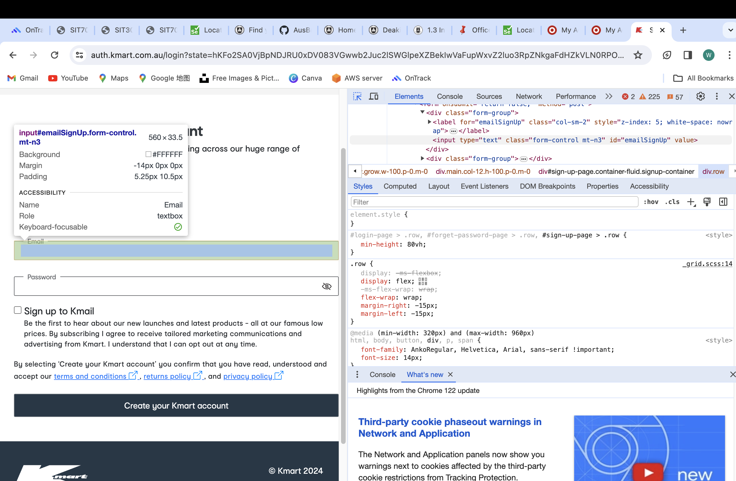

1. Your program’s source code (SeleniumOperations.java and the function you created for the alternative website).
2. Officework
3. **package** sit707_week2;
4. **import** java.io.File;
5. **import** org.apache.commons.io.FileUtils;
6. **import** org.openqa.selenium.By;
7. **import** org.openqa.selenium.OutputType;
8. **import** org.openqa.selenium.TakesScreenshot;
9. **import** org.openqa.selenium.WebDriver;
10. **import** org.openqa.selenium.WebElement;
11. **import** org.openqa.selenium.chrome.ChromeDriver;
12. /**
13. * This class demonstrates Selenium locator APIs to identify HTML elements.
14. *
15. * Details in Selenium documentation https://www.selenium.dev/documentation/webdriver/elements/locators/
16. *
17. * **@author** yuheng wang
18. */
19. **public** **class** SeleniumOperations {
20. **public** **static** **void** sleep(**int** sec) {
21. **try** {
22. Thread.*sleep*(sec*1000);
23. } **catch** (InterruptedException e) {
24. // **TODO** Auto-generated catch block
25. e.printStackTrace();
26. }
27. }

30. **public** **static** **void** officeworks_registration_page(String url) {
31. // Step 1: Locate chrome driver folder in the local drive.
32. System.*setProperty*("webdriver.chrome.driver", "/Users/yuhengwang/Desktop/IT material/2024 T1/SIT707 software testing/chromedriver-mac-x64/chromedriver");
34. // Step 2: Use above chrome driver to open up a chromium browser.
35. System.***out***.println("Fire up chrome browser.");
36. WebDriver driver = **new** ChromeDriver();
38. System.***out***.println("Driver info: " + driver);
40. *sleep*(2);
42. // Load a webpage in chromium browser.
43. driver.get(url);
45. /*
46. * How to identify a HTML input field -
47. * Step 1: Inspect the webpage,
48. * Step 2: locate the input field,
49. * Step 3: Find out how to identify it, by id/name/...
50. */
52. // Find first input field which is firstname
53. WebElement element = driver.findElement(By.*id*("firstname"));
54. System.***out***.println("Found element: " + element);
55. // Send first name
56. element.sendKeys("yuheng");
58. /*
59. * Find following input fields and populate with values
60. */
61. // Write code
62. // find last name
63. WebElement element2 = driver.findElement(By.*id*("lastname"));
64. System.***out***.println("Found element: " + element2);
65. // Send last name
66. element2.sendKeys("wang");
67. //find phoneNumber
68. WebElement element3 = driver.findElement(By.*id*("phoneNumber"));
69. System.***out***.println("Found element: " + element3);
70. // Send phoneNumber
71. element3.sendKeys("0419292770");
72. //find email
73. WebElement element4 = driver.findElement(By.*id*("email"));
74. System.***out***.println("Found element: " + element4);
75. // Send email
76. element4.sendKeys("wangyuheng086@gmail.com");
77. //find password
78. WebElement element5 = driver.findElement(By.*id*("password"));
79. System.***out***.println("Found element: " + element5);
80. // Send password
81. element5.sendKeys("123456");
82. /*
83. * Identify button 'Create account' and click to submit using Selenium API.
84. */
85. // Write code
86. WebElement createAccountButton = driver.findElement(By.*xpath*("/html/body/div[2]/div/div[1]/div/div/form/div[12]/button"));
87. createAccountButton.click();
88. /*
89. * Take screenshot using selenium API.
90. */
91. // Write code
92. File screenshot = ((TakesScreenshot)driver).getScreenshotAs(OutputType.***FILE***);
93. **try** {
94. FileUtils.*copyFile*(screenshot, **new** File("/Users/yuhengwang/Desktop/IT material/2024 T1/SIT707 software testing/task2_1P/screenShot.png"));
95. } **catch** (Exception e) {
96. e.printStackTrace();
97. }
99. // Sleep a while
100. *sleep*(2);
102. // close chrome driver
103. driver.close();
104. }

107. }
108. Target
109. **package** sit707_week2;
110. **import** java.io.File;
111. **import** java.time.Duration;
112. **import** org.apache.commons.io.FileUtils;
113. **import** org.openqa.selenium.By;
114. **import** org.openqa.selenium.OutputType;
115. **import** org.openqa.selenium.TakesScreenshot;
116. **import** org.openqa.selenium.WebDriver;
117. **import** org.openqa.selenium.WebElement;
118. **import** org.openqa.selenium.chrome.ChromeDriver;
119. **import** org.openqa.selenium.support.ui.ExpectedConditions;
120. **import** org.openqa.selenium.support.ui.WebDriverWait;
121. **public** **class** testTargetWebsite {
122. **public** **static** **void** sleep(**int** sec) {
123. **try** {
124. Thread.*sleep*(sec*1000);
125. } **catch** (InterruptedException e) {
126. // **TODO** Auto-generated catch block
127. e.printStackTrace();
128. }
129. }

132. **public** **static** **void** officeworks_registration_page(String url) {
133. // Step 1: Locate chrome driver folder in the local drive.
134. System.*setProperty*("webdriver.chrome.driver", "/Users/yuhengwang/Desktop/IT material/2024 T1/SIT707 software testing/chromedriver-mac-x64/chromedriver");
136. // Step 2: Use above chrome driver to open up a chromium browser.
137. System.***out***.println("Fire up chrome browser.");
138. WebDriver driver = **new** ChromeDriver();
140. System.***out***.println("Driver info: " + driver);
142. *sleep*(2);
144. // Load a webpage in chromium browser.
145. driver.get(url);
147. WebDriverWait wait = **new** WebDriverWait(driver, Duration.*ofSeconds*(10));
148. WebElement createAccountButton = wait.until(ExpectedConditions.*elementToBeClickable*(By.*xpath*("//button[@id='createAccount']")));
149. createAccountButton.click();
150. // More reliable element locator
151. WebElement firstNameField = wait.until(ExpectedConditions.*visibilityOfElementLocated*(By.*name*("firstName")));
152. firstNameField.sendKeys("yuheng");

155. //Identify button 'Create account' and click to submit using Selenium API.
157. // Write code
158. // WebElement createAccountButton = driver.findElement(By.xpath("/html/body/div[2]/div/div[1]/div/div/form/div[12]/button"));
159. // createAccountButton.click();
160. /*
161. * How to identify a HTML input field -
162. * Step 1: Inspect the webpage,
163. * Step 2: locate the input field,
164. * Step 3: Find out how to identify it, by id/name/...
165. */
167. // Find first input field which is firstname
168. WebElement element = driver.findElement(By.*id*("first-name"));
169. System.***out***.println("Found element: " + element);
170. // Send first name
171. element.sendKeys("yuheng");
173. /*
174. * Find following input fields and populate with values
175. */
176. // Write code
177. // find last name
178. WebElement element2 = driver.findElement(By.*id*("last-name"));
179. System.***out***.println("Found element: " + element2);
180. // Send last name
181. element2.sendKeys("wang");
182. //find phoneNumber
183. WebElement element3 = driver.findElement(By.*id*("mobile-number"));
184. System.***out***.println("Found element: " + element3);
185. // Send phoneNumber
186. element3.sendKeys("0419292770");
187. //find email
188. WebElement element4 = driver.findElement(By.*id*("signup-email"));
189. System.***out***.println("Found element: " + element4);
190. // Send email
191. element4.sendKeys("wangyuheng086@gmail.com");
192. //find password
193. WebElement element5 = driver.findElement(By.*id*("signup-password"));
194. System.***out***.println("Found element: " + element5);
195. // Send password
196. element5.sendKeys("123456");
197. /*
198. * Identify button 'Create account' and click to submit using Selenium API.
199. */
200. // Write code
201. // WebElement createAccountButton = driver.findElement(By.xpath("//*[@id=\"btn-signup\"]"));
202. // createAccountButton.click();
203. /*
204. * Take screenshot using selenium API.
205. */
206. // Write code
207. File screenshot = ((TakesScreenshot)driver).getScreenshotAs(OutputType.***FILE***);
208. **try** {
209. FileUtils.*copyFile*(screenshot, **new** File("/Users/yuhengwang/Desktop/IT material/2024 T1/SIT707 software testing/task2_1P/screenShot.png"));
210. } **catch** (Exception e) {
211. e.printStackTrace();
212. }
214. // Sleep a while
215. *sleep*(2);
217. // close chrome driver
218. driver.close();
219. }
220. }
221. Kmart
222. **package** sit707_week2;
223. **import** java.io.File;
224. **import** java.time.Duration;
225. **import** org.apache.commons.io.FileUtils;
226. **import** org.openqa.selenium.By;
227. **import** org.openqa.selenium.OutputType;
228. **import** org.openqa.selenium.TakesScreenshot;
229. **import** org.openqa.selenium.WebDriver;
230. **import** org.openqa.selenium.WebElement;
231. **import** org.openqa.selenium.chrome.ChromeDriver;
232. **import** org.openqa.selenium.support.ui.ExpectedConditions;
233. **import** org.openqa.selenium.support.ui.WebDriverWait;
234. **public** **class** testKmart {
235. **public** **static** **void** sleep(**int** sec) {
236. **try** {
237. Thread.*sleep*(sec*1000);
238. } **catch** (InterruptedException e) {
239. // **TODO** Auto-generated catch block
240. e.printStackTrace();
241. }
242. }

245. **public** **static** **void** officeworks_registration_page(String url) {
246. // Step 1: Locate chrome driver folder in the local drive.
247. System.*setProperty*("webdriver.chrome.driver", "/Users/yuhengwang/Desktop/IT material/2024 T1/SIT707 software testing/chromedriver-mac-x64/chromedriver");
249. // Step 2: Use above chrome driver to open up a chromium browser.
250. System.***out***.println("Fire up chrome browser.");
251. WebDriver driver = **new** ChromeDriver();
253. System.***out***.println("Driver info: " + driver);
255. *sleep*(2);
257. // Load a webpage in chromium browser.
258. driver.get(url);



263. //Identify button 'Create account' and click to submit using Selenium API.
265. // Write code
266. // WebElement createAccountButton = driver.findElement(By.xpath("/html/body/div[2]/div/div[1]/div/div/form/div[12]/button"));
267. // createAccountButton.click();
268. /*
269. * How to identify a HTML input field -
270. * Step 1: Inspect the webpage,
271. * Step 2: locate the input field,
272. * Step 3: Find out how to identify it, by id/name/...
273. */
275. // Find first input field which is firstname
276. WebElement element = driver.findElement(By.*id*("first-name"));
277. System.***out***.println("Found element: " + element);
278. // Send first name
279. element.sendKeys("yuheng");
281. /*
282. * Find following input fields and populate with values
283. */
284. // Write code
285. // find last name
286. WebElement element2 = driver.findElement(By.*id*("last-name"));
287. System.***out***.println("Found element: " + element2);
288. // Send last name
289. element2.sendKeys("wang");
291. //find email
292. WebElement element4 = driver.findElement(By.*id*("signup-email"));
293. System.***out***.println("Found element: " + element4);
294. // Send email
295. element4.sendKeys("wangyuheng086@gmail.com");
296. //find password
298. /*
299. * Identify button 'Create account' and click to submit using Selenium API.
300. */
301. // Write code
302. // WebElement createAccountButton = driver.findElement(By.xpath("//*[@id=\"btn-signup\"]"));
303. // createAccountButton.click();
304. /*
305. * Take screenshot using selenium API.
306. */
307. // Write code
308. File screenshot = ((TakesScreenshot)driver).getScreenshotAs(OutputType.***FILE***);
309. **try** {
310. FileUtils.*copyFile*(screenshot, **new** File("/Users/yuhengwang/Desktop/IT material/2024 T1/SIT707 software testing/task2_1P/screenShot.png"));
311. } **catch** (Exception e) {
312. e.printStackTrace();
313. }
315. // Sleep a while
316. *sleep*(2);
318. // close chrome driver
319. driver.close();
320. }
321. }

5. Github

https://github.com/AusBruce/sit707-week2-2.1P.git

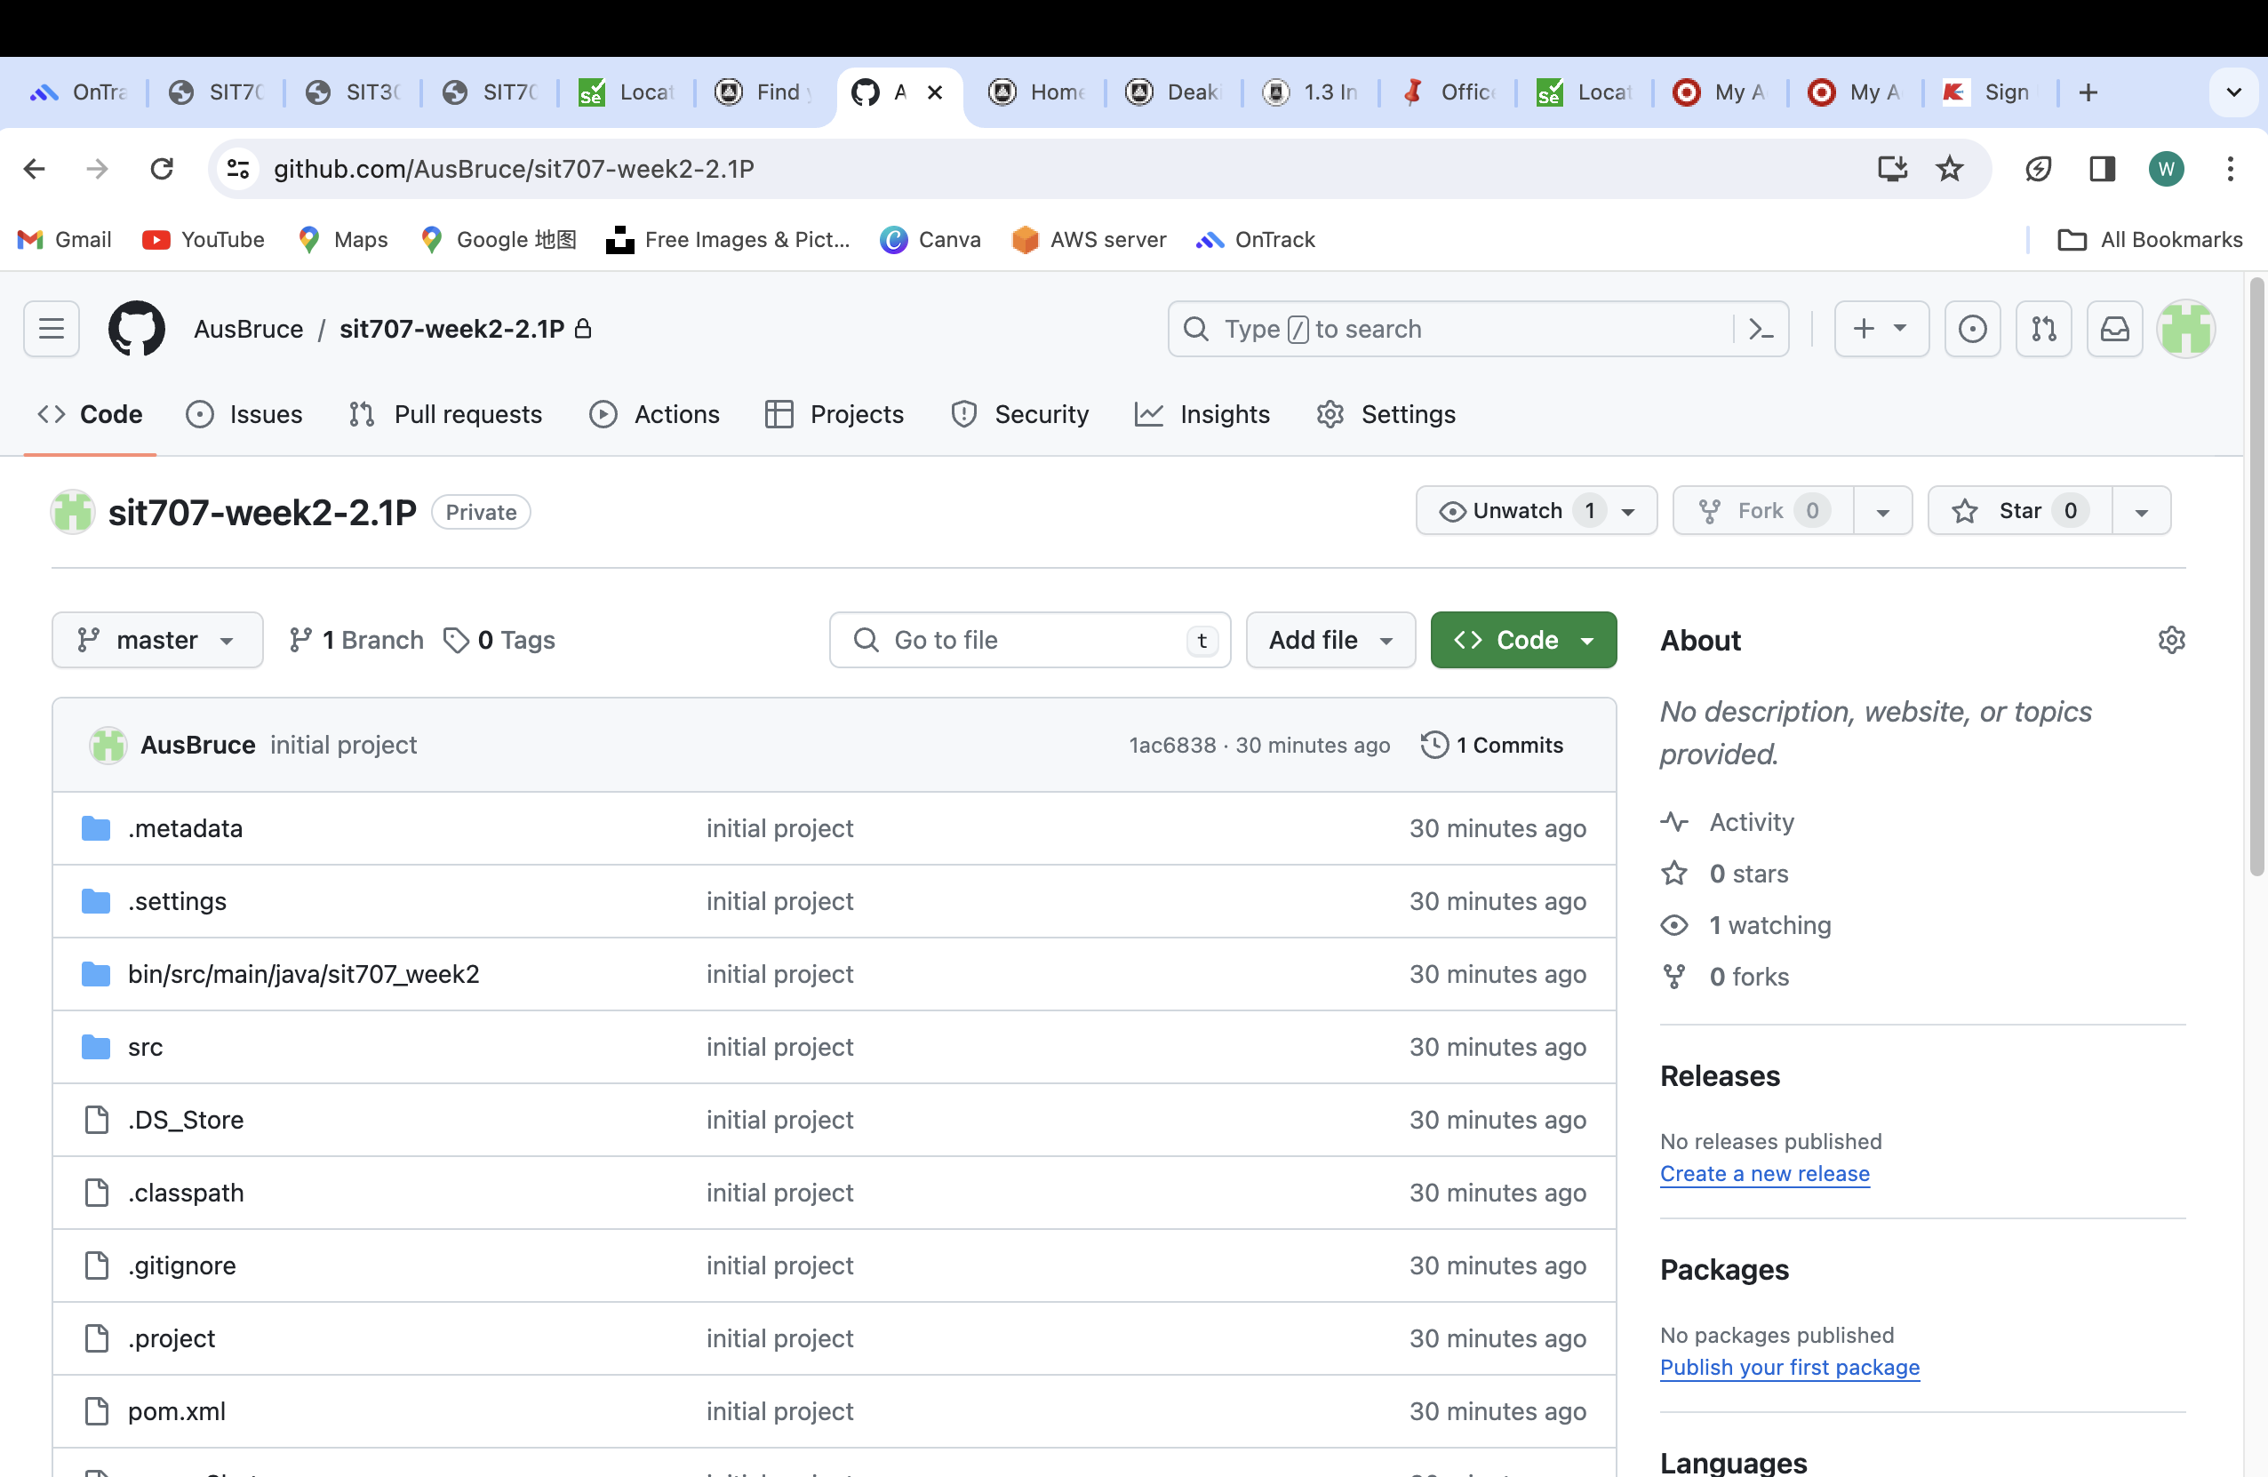hub